Department of Software Engineering (SWE)

Faculty of Science & Information Technology (FSIT)

# Daffodil International University (DIU)

## Daffodil Smart City, Birulia, Savar, Dhaka-1216, Bangladesh

Notice for Advisor Change-Spring 2025

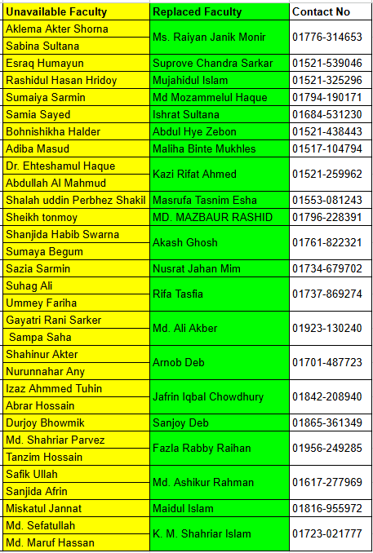This is to inform that due to the unavailability of certain faculty members (Highlighted in Yellow), the responsibilities for Registration have been assigned to replacement faculty members (Highlighted in Green). Students are advised to complete their Registration with the respective assigned faculty members.