

**Daffodil International University**

**Department of Software Engineering**

**19 Oct 2025**

**OVERLAP EXAM NOTICE FOR Mid/Final-Term**

**EXAMINATION Fall 2025**

Students of Department of Software Engineering are hereby notified that the

**Overlap Examination** of Mid/Final Fall 2025 will be held on **according to main routine schedule. Check the Mid/Final Exam Routine.**

All students are advised to submit an application **within 29-10-2025** to the **Software Engineering Department Office (Ms. Jui Jenifer Gomes, Assistant Coordination Officer)** with the signature of the both courseteachers which are overlapped with each other and signature of the batch adviser also.

**\*\*\*Two Examinations in the same day but at different time slots will not be considered as Overlap Examination.**

**No student will be allowed to sit without application or fake application. If found, the answer script will be rejected by the Exam committee member.**

### Overlap Exam Policy (Applicable for Midterm & Final Examination)

1. **Collect the Overlap Form**
   * Visit the Department Office and collect the **Overlap Form** from  
      ***Ms. Jui Jenifer Gomes, Assistant Coordination Officer.***
2. **Fill Out the Form**
   * Provide all required information accurately.
3. **Get Necessary Signatures**
   * Take signatures from both your **Course Teacher** and **Mentor**.
4. **Submit the Form**
   * Submit the completed form to the **Department Office** (Ms. Jui Jenifer Gomes).
5. **Check Overlap Routine** * Visit the **SWE Web Notice Portal** for Overlap Exam Routine.

**Demographic View:**

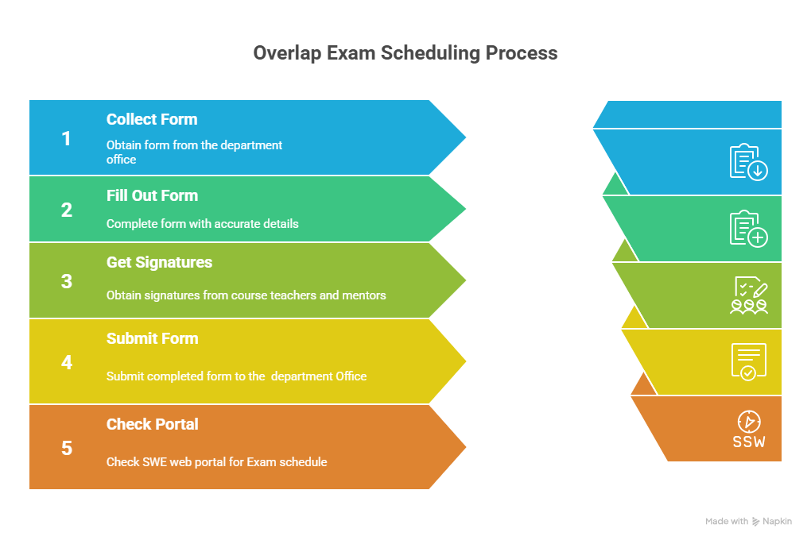

### Improvement Exam Policy (Applicable for Final Examination only)

1. **Wait for Official Notice**
   * Wait for the **DIU Improvement Exam Notice** sent to your **DIU Student Mail**.
2. **Collect the Improvement Form**
   * Collect the form from the **Department Office** (Ms. Jui Jenifer Gomes, Assistant Coordination Officer).
3. **Fill Out the Form**
   * Complete all required information accurately.
4. **Get Signature and Make Payment**
   * Take the signature of your **Course Teacher & Mentor**.
   * Make the required payment at the **Accounts Section** and obtain the **seal** from Accounts.
5. **Submit the Form**
   * Submit the completed form to the **Department Office** (Ms. Jui Jenifer Gomes).
6. **Check Notice Portal**

* Visit the **SWE Web Notice Portal** regularly for updates regarding **Exam** schedules.

**Demographic View:**

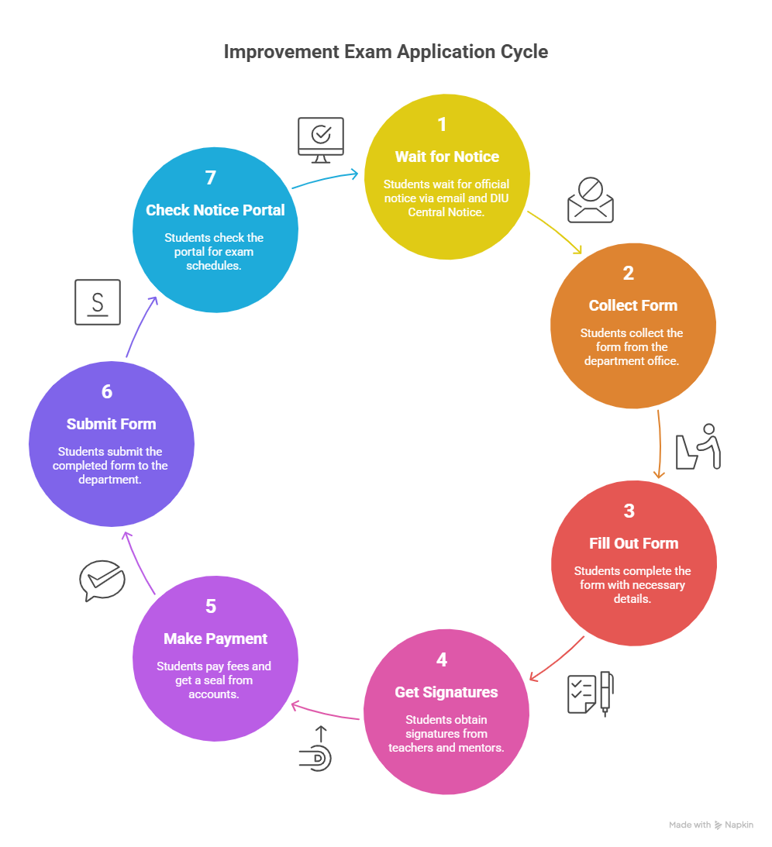

**Special Case: (Applicable for Midterm & Final Examination)**

**If you miss your exam (mid-term or final-term) for other reason, asked to send email to** [**sweoffice3@daffodilvarsity.edu.bd**](mailto:sweoffice3@daffodilvarsity.edu.bd) **keep cc your academic mentor/advisor with valid prove documents. Then wait for the confirmation whether you allow or not.**

**Overlap Mid/Final-Term Exam Application Format**

...................... (Write Date Here)

To

The Member of Exam Committee,

Department of Software Engineering

Daffodil International University

Daffodil Smart City. Birulia, Savar Dhaka 1216.

**Subject: Application for attending the Overlap of Mid/Final Exam in Fall 2025.**

Dear Sir,

I am ***(Name)*** , a regular student in your university. My ***(which semester you are)*** semester final

exam routine is published. This time after getting my exam routine I have noticed that two of my courses

are in the same day as well as the same time slot. It is not possible for me to attend two courses at the same time.

**Details for Overlap course:**

|  |  |  |  |  |
| --- | --- | --- | --- | --- |
| **Acknowledgement** | **Course Code** | **Course title** | **Teacher Initial** | **Teacher Signature** |
| **I will attend this course of overlap exam.** |  |  |  |  |
| **I will attend this course at schedule time.** |  |  |  |  |
| **I am informed that**  **My student is**  **attending Overlap**  **Examination** | **Name of Adviser:**  **Advisor Comment :** | | | **Signature of Adviser :** |

Therefore, I pray and hope that you will be kind enough to permit me to attend an overlap course at the time of overlap / Improvement.

Yours Obediently,

Student Name:

Student ID:

Section:

Batch:

Mobile:

Email: