Daffodil International University

Department of Software Engineering (SWE)

Project/Thesis Committee

May 12, 2025

**NOTICE**

This is to notify that 37 Batch students for final Year Project/Thesis are asked to submit their Project/Thesis proposal by **29/05/2025**. In order to submit the Project/Thesis proposal, students are asked to fill up the proposal form. Instruction mentions below,

Before go through the instruction please join google class using Code: **kv2wpy5j**

**Eligibility for Thesis/Project/Internship**

* Those who are going to complete at least 105 credits till now, are eligible to submit the proposal for Final year Project/Thesis.
* **Thesis (General):** Students must have **3.00** CGPA to apply for Thesis. For less CGPA Dept. and Thesis/Project Committee will decide later by their

Fixed criteria.

* **Project (General):** Any student can take the project but you must be followed **SDLC** to complete the project. We highly discourage the so-called

Old management system project. Students must have knowledge in both Back end and front-end development for the project.

* **Project (Industry):** Students must have **3.00** CGPA. Students must work for renowned **software companies** for **Industry project** and must work on

**SDLC Steps**. **Industry project** time is a minimum of **4 months** and you must submit an **appointment letter** to the Thesis/Project Committee. After filling all the criteria, the Thesis/Project Committee will inform you about the result.

If the result is negative then you have to take the project to complete your degree.

* **Thesis (Industry):** Students must have **3.00** CGPA. Students must work on

**renowned software companies** for **Industry Thesis**. After filling all the

criteria, the Thesis/Project Committee will inform you about the result. If the result is negative then you have to take the project to complete your degree.

* **No group allowed, Individual Task.**

**Please follow the following instructions very carefully.**

1. **Go to website (**[**http://swe.application.daffodilvarsity.edu.bd/final_project/public/register**](http://swe.application.daffodilvarsity.edu.bd/final_project/public/register)**)**
2. **Complete Registration (Fill up Name, Valid email address, Password)**

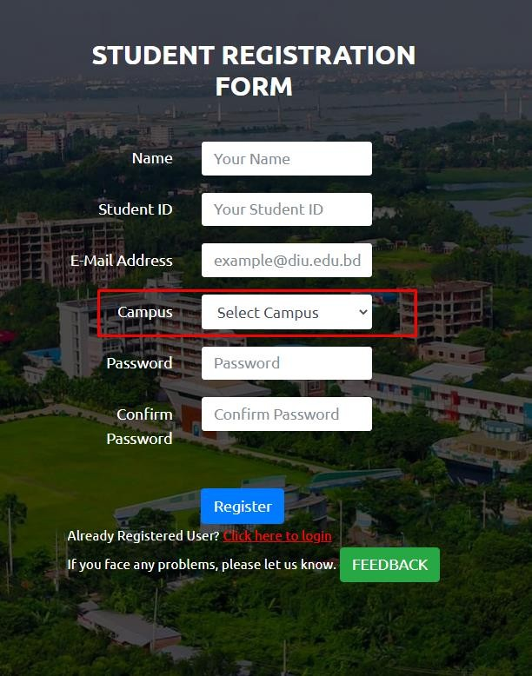

.

1. **If you are already registered you can be logged in using your student email id and your password.**

**Url:** [**http://swe.application.daffodilvarsity.edu.bd/final_project/public/login**](http://swe.application.daffodilvarsity.edu.bd/final_project/public/login)

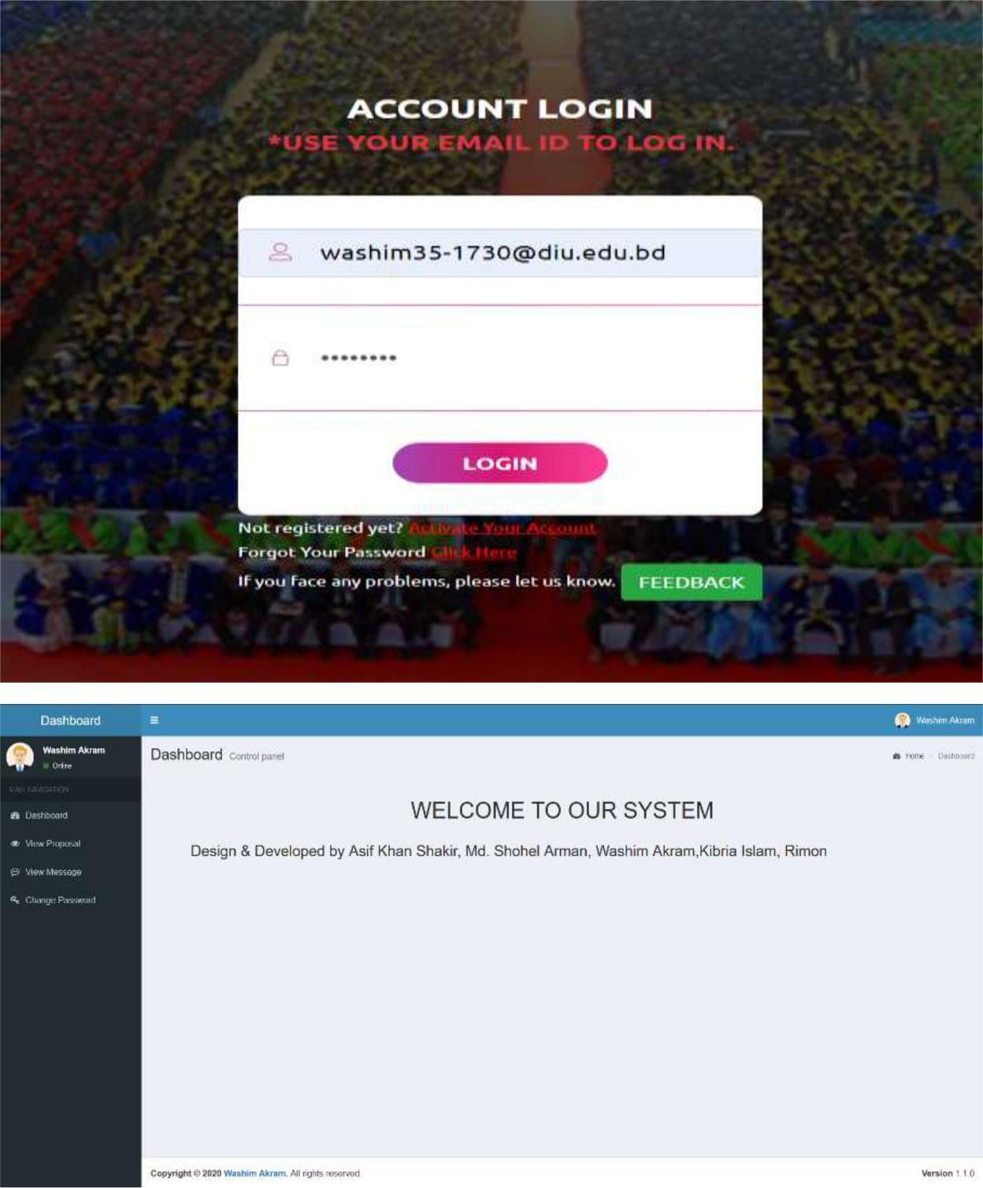

1. **Submit your Proposal Click Here:**

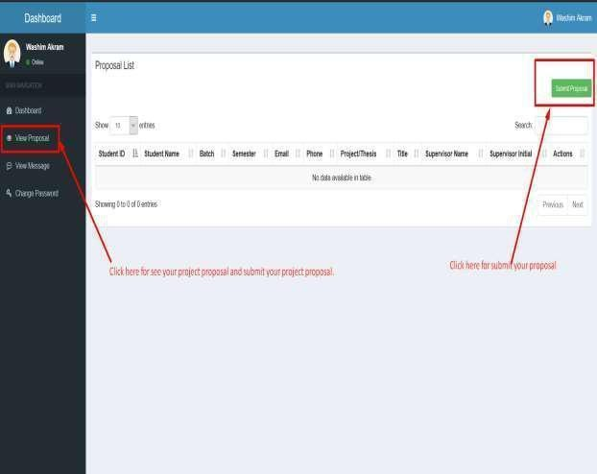

1. **Fill up the proposal form and click submit button. (Fill up Student ID, Batch, Semester, Phone Number, Study, CGPA, Project/Thesis/Internship, Title, Description, * If you want then you can change your name.)**

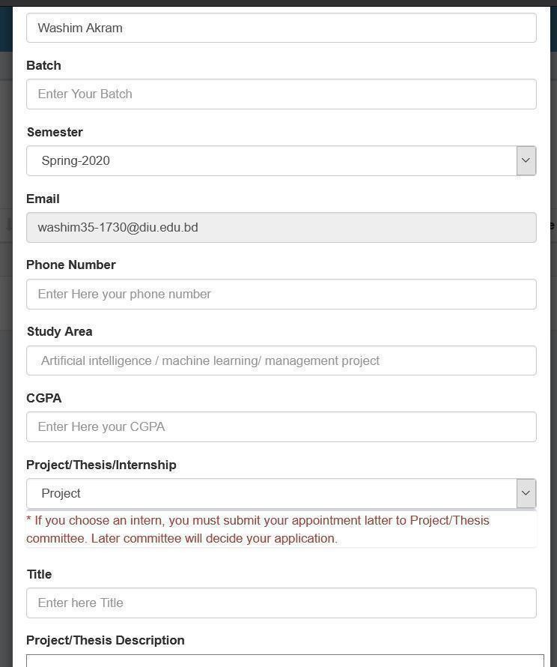

1. **Click View proposal button and see your proposal accepted or pending.**

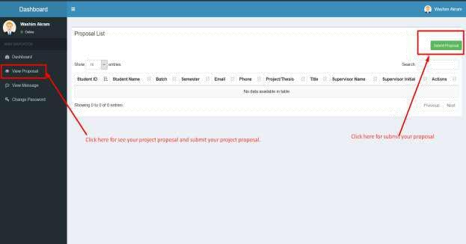

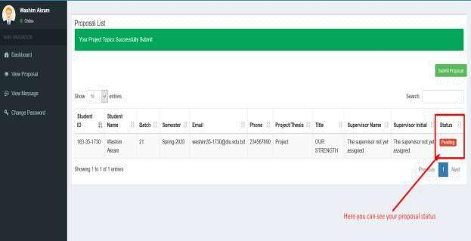

1. **Click view message button and you can see your task.**

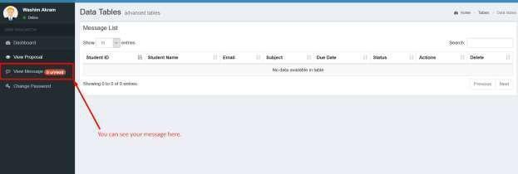

1. **Click view details button then you can see details task.**

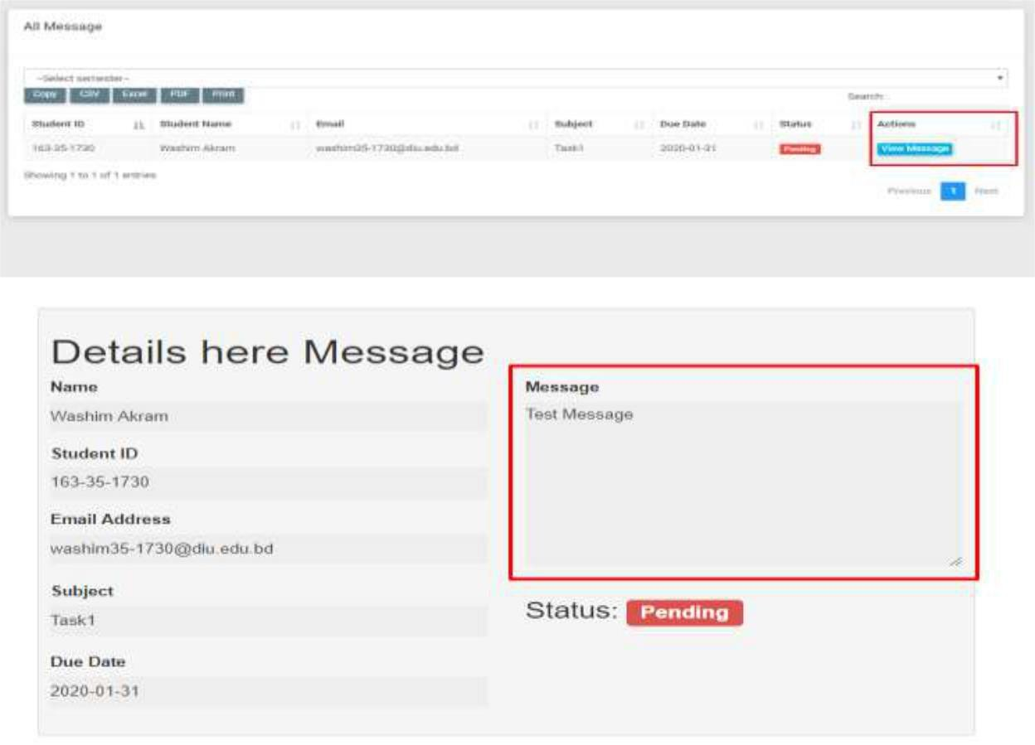

1. **Here you can see notice.**

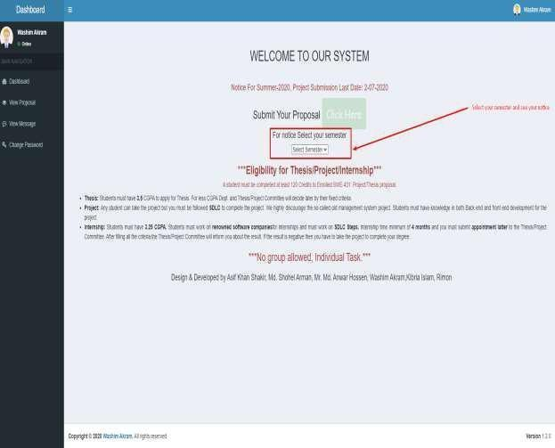

**NB: After 29 May 2025 no proposal will be accepted.

**NB: For further queries contact with this email: [khalid@daffodilvarsity.edu.bd,](mailto:khalid@daffodilvarsity.edu.bd,) [rajib.swe@diu.edu.bd](mailto:rajib.swe@diu.edu.bd)

Dr. Fazla Elahe, Khalid Been Badruzzaman Biplob, Md Rajib Mia, Dr Marzia Ahmed, Suprove Chandra Sarkar. Member Project/Thesis Committee Department of Software Engineering